Linear plasmid
Linear plasmids—as their circular counterparts—are extrachromosomal DNA elements. They have been found in a wide variety of both prokaryotic and eukaryotic organisms.
Firstly, discovered in maize, they not only exist in higher plants, but also in filamentous fungi and yeasts, such as Morchella conica and Kluyveromyces lactis, respectively.
Among bacteria, linear elements are found in spirochaetes, Gram-negative and Gram-positive species. The majority, however, is found in the latter group, particularly in Actinomycetes including the genera Streptomyces, Rhodococcus, Micrococcus, and Brevibacterium.
While eukaryotic linear plasmids are typically rather short, ranging in size from1.1kb to about 20kb, such as pDP1(18kb) of Debaryomyces polymorphus, bacterial elements are generally larger. They may reach lengths of several hundreds of kilobases, for instance pRHL2 (443kb) of Rhodococcus jostii RHA1.
Extreme examples are pSCL4 (1.8Mb) of Streptomyces clavuligerus ATCC27064 and the only12-kb spanning pSCL1 of Streptomyces clavuligerus. Extremely large elements are frequently denoted as mega or giant linear plasmids.
Cellular localization of linear plasmid differs in both eukaryotes and prokaryotes. While in higher plants and filamentous fungi linear plasmids were exclusively found in mitochondria, in bacteria and yeasts a cytoplasmic localization is generally reported.
Among yeasts, pPH1of Pichia heedi and pPK1of Pichia kluyveri represent an exception, as they reside in the mitochondria. Moreover, the linear plasmid of Chlamydomonas moewusii, a green algae, is chloroplast-associated.
Based on molecular differences, linear plasmids belong to one of two types, those with covalently closed ends into hairpin elements and those with proteins bound to their 5' termini.
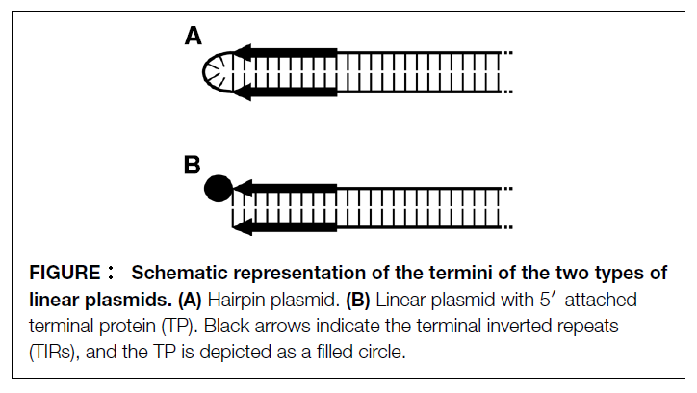
Hair pin elements are characterized by terminal loops formed at each end of the plasmid due to covalent linkage of the two single DNA strands. Moreover, each of the termini display short inverted repeats (terminal inverted repeats, TIRs). Elements of this type were found in representatives of the genus Borrelia such as Borrelia hermsii and Borrelia burgdorferi, which are known as causative agents of relapsing fever and Lyme borreliosis, respectively.
The other type of linear DNA-elements possesses termini to which proteins (terminal proteins, TPs) are covalently attached to bothofthe5′-ends. TIRs are likewise present. Members of this group of linear elements occur more frequently; they were found in a number of filamentous fungi, bacteria, and yeasts as well as in plants.
Linear plasmids may provide advantageous attributes to their hosts, many of them concern metabolic and physiological traits including catabolic gene clusters conferring the ability to degrade and metabolize a wide spectrum of organic compounds. Such catabolic linear elements are frequently found in soil bacteria, in particular in Rhodococci.
Plasmid-borne resistances, allowing their hosts to tolerate heavy metals, such as arsenic and mercury, and antibiotics, have been reported, for a number of Streptomyces species, some Rhodococci, and in Micrococcus.
As a distinctive feature, most of the linear plasmids originating from Actinobacteria are capable of conjugal transfer.

